Sexual assault and domestic violence

What is sexual harassment?
Under NSW law, sexual harassment is:
- unwanted sexual advances
- unwelcome requests for sexual favours
- other unwelcome conduct of a sexual nature
These can take the form of:
- staring in a sexual manner
- ‘wolf-whistling’
- repeated sexual invitations when the person has previously refused similar invitations
- initiation ceremonies involving unwelcome sexual behaviour
- comments about a person's physical appearance or sexual characteristics
- intrusive questions about sexual activity
- image-based sexual abuse, which includes non-consensual taking or creation of nude or sexual images, non-consensual distribution of nude or sexual images and threats to create and/or distribute nude or sexual images (see cyberlaw)
More information about sexual harassment from the Anti-Discrimination Board of NSW.

What is sexual assault?
Sexual assault is any sexual behaviour by one or more people, against another person without that person’s consent. Consent, in this instance, means explicitly agreeing to engage in any sexual activity.
By NSW law, consent must be given freely and voluntarily by a person who has the capacity to give that consent. This means the person must not have consumed drugs or alcohol to the extent that they’re intoxicated and incapable of consenting.

Silence does not equal consent.
Sexual assault includes unwanted sexual or physical contact, such as slapping, kissing, touching, hugging or massaging.
Sexual assault is also: sexual abuse, rape, indecent behaviour, indecent assault, sexual molestation, incest, child sexual abuse, child sexual assault, touching, ‘feeling up’.
It is most commonly committed against women and children by men they know, such as boyfriends, fathers, neighbours, step-fathers, bosses, uncles, husbands or partners.
If you’re not sure whether you have been sexually assaulted or not, you can contact a sexual assault service or a legal service, such as our Legal Service, for advice.

How to report an incident or file a complaint
If you’ve experienced sexual harassment or assault while at uni, or witnessed someone else being the victim of an assault, you can make a complaint or report the incident to the University. This is known as a disclosure. You can make a disclosure either by contacting a Student Liaison Officer or using the online Sexual Assault and Sexual Harassment Portal.
A disclosure is letting the University know about the incident, while a complaint means you want the incident investigated and are seeking some form of action against the person who harassed or assaulted you. A complaint will usually require a more detailed report. You can contact a Student Liaison Officer and report over the phone, by email or arrange a face-to-face meeting. Or you can make a complaint to the Student Affairs Unit. Alternatively you may find it easier to report by using the online portal.
Whichever way you report, the Student Liaison Officers can help by assisting you with applications for special consideration for assessments, changing classes or timetables, housing arrangements, financial assistance, counselling, and other support services.
If you’re feeling too overwhelmed or distressed to make either a disclosure or a complaint, our caseworkers can support you through the process, and discuss your options. Contact us to set up an appointment.
For further guidance you can also refer to the University’s policy and procedures on sexual assault and sexual harassment:
- Student Sexual Misconduct Policy 2018
- Student Sexual Misconduct Response Procedures 2018

If you’ve been sexually assaulted
1. It is not your fault.
2. Make sure you’re safe or contact someone you trust. If you’re in immediate danger contact Campus Security on 02 9351 3333 or the police on 000.
3. Seek professional help: visit a medical centre or hospital, and counselling support.
4. Consider reporting the assault to the police.

RPA Sexual Assault Service (24 hours)
RPA is the closest hospital emergency department to the Camperdown/Darlington campus. Contact them for immediate assistance.
(02) 9515 9040
After hours: (02) 9515 6111

NSW Rape Crisis Centre
Contact for advice and support at any stage.
1800 424 017 (24 hours)

University contacts and resources
Confidential helpline: 1800 SYD HLP (1800 793 457)
Student Liaison Officers email: safer-communities.officer@sydney.edu.au
The University’s sexual assault information, contacts and resources
Download the University’s support for student survivors document (pdf)
Counselling and Psychological Services (CAPS): (02) 8627 8433 or caps.admin@sydney.edu.au

SUPRA
(02) 9351 3715
help@supra.usyd.edu.au

1800 Respect
24 hour sexual assault, domestic and family violence counselling service
1800 RESPECT (1800 737 732)
1800respect.org.au

Muslim Women Association
(02) 9750 6916
mwa.org.au

Shakti NSW (migrant and refugee women)
1800 SHAKTI (1800 742 584)
sydney@shaktiaustralia.org.au
www.shakti-international.org

Bystander intervention
We encourage you to be an active bystander. If you notice an interaction or see someone who seems distressed, intervene if it’s safe to do so. If it seems unsafe to intervene and you feel concerned for someone else’s safety, call Campus Security on 02 9351 3333 or the police on 000.

Family and domestic violence
Family and domestic violence (often referred to as DV) is abusive, intimidating behaviour carried out by a partner, family member or carer, to control, dominate or instill fear. DV may be physical, psychological, emotional, financial, sexual, cultural or spiritual. It can also include cyber abuse, stalking and separation violence. Women and children make up the majority of victims of domestic and family violence.
DV affects all communities and demographics, including same-sex relationships, trans and gender diverse people, people with disabilities and Aboriginal and Torres Strait Islander people. While each person’s experience may be different, DV tends to follow a cycle of abuse.

The cycle of abuse
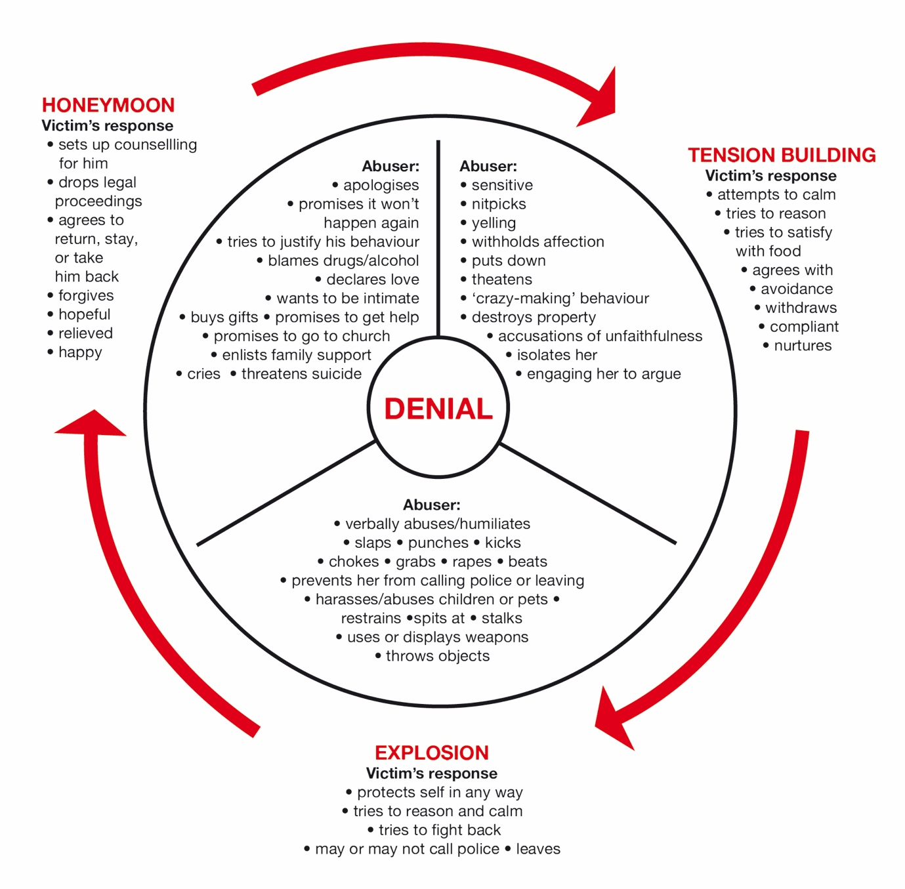
(graphic adapted from whiteribbon.org.au)

Taking steps to seek support and break the cycle
If you’re in an abusive relationship, leaving may be difficult. There are many specialist services that can offer support, guidance and resources to help you. They’re available if you just want to talk, or if you’re thinking of leaving. These services can help you put a safety plan in place.
Our Postgraduate Advocacy Service can assist you with all university and academic matters, such as assistance with special consideration for any assessments affected by your experience of DV, and provide referrals to services that can help you secure safe accommodation, counselling and ongoing support. Our Legal Service can assist you with any and all areas of the law you may need assistance in, including helping you to secure legal protections.

Emergency
In an emergency call 000. Police will attend and take immediate action to protect you and anyone else in danger, such as children and pets. The police may file an Apprehended Domestic Violence Order (ADVO) on your behalf, which ensures the perpetrator or person hurting you will be prohibited from coming near you.
The police also have specialist Domestic Violence Liaison Officers known as DVLOs. For people from the LGBTQI+ community, there are special officers known as Gay and Lesbian Liaison Officers (GLLOs). For people from Aboriginal and Torres Strait Islander communities, these special officers are known as Aboriginal Community Liaison Officers (ACLOs). You can call your local police station and make an appointment to speak to any of these specialist officers. This can allow you to safely plan a time that suits you, and arrange a support person to accompany you, if you wish.

Further information
If you need further advice or assistance contact us, our Legal and Advocacy Services can help you.

Resources and support services
24 hour Domestic Violence Line
1800 656 463 (toll free)
www.facs.nsw.gov.au/domestic-violence/helpline
Domestic violence info: www.facs.nsw.gov.au/domestic-violence
Domestic violence legal advice line (Women’s Legal Service NSW)
(02) 8745 6999 or 1800 810 784
LGBTQI Safe Relationships Project/Inner City Legal Centre
1800 244 481
www.iclc.org.au/safe-relationships-project
QLife
Anonymous and free LGBTI peer support and referral.
1800 184 527 (3pm - 12 midnight, 7 days)
Webchat: qlife.org.au/resources/chat
ACON
LGBTI health and HIV/AIDS Organisation
1800 063 060
sayitoutloud.org.au
www.acon.org.au/what-we-are-here-for/domestic-family-violence
The Gender Centre and the Transgender Anti Violence Project (TAVP)
(02) 9519 7599 - 9am to 4:30pm Monday to Friday
gendercentre.org.au/services/counselling-services
gendercentre.org.au/services/transgender-anti-violence-project
Wirringa Baiya – Aboriginal Women’s Legal Centre
1800 686 587 or info@wirringabaiya.org.au
www.wirringabaiya.org.au
Mudgin-Gal – Aboriginal Women’s Place
(02) 9698 1173
Indigenous Women’s Legal Contact Line (Women’s Legal Service NSW)
(02) 8745 6977 or 1800 639 784
Link2home (homelessness information and referral)
Domestic violence line: 1800 656 463
General line: 1800 152 152
University Accommodation Service
(02) 9351 3322
National Relay Service (NRS)
Phone service for people who are deaf or hearing-impaired.
Voice relay: 1300 555 727
TTY: 133 677
SMS relay: 0423 677 767
All NRS phone numbers including emergency calls

Disclaimer
This information is current as at December 2019 and where it includes legal information is intended as a guide to the law as it applies to people who live in or are affected by the law as it applies in NSW. It does not constitute legal advice.
Last updated Feb 2020

