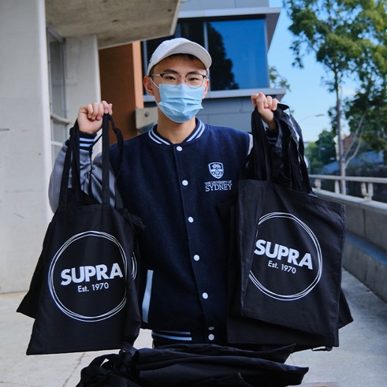

2020

SUPRA Annual Report

SUPRA 2020 Annual Report

Sydney University Postgraduate Representative Association
Level 2, Holme Building, Science Road, Camperdown Campus
The University of Sydney NSW 2006
supra.net.au | help@supra.usyd.edu.au | 02 9351 3715

Acknowledgement of Country
SUPRA acknowledges the Gadigal people of the Eora nation as the owners of the land we work and study on at the University of Sydney.
We also acknowledge the traditional owners of the lands we have worked and studied from during the COVID-19 pandemic.
This always was and always will be Aboriginal land.

Contents

Celebrating 50 years of SUPRA 5
Council reports 7
Co-Presidents 8
Co-Vice Presidents 10
Co-Secretaries 12
Treasurer 14
Co-Education Officers 16
Director of Student Publications 18
Queer Officer 25
Aboriginal and Torres Strait Islander Officer 26
Co-Women’s Officers 27
Co-International Officers 29
Satellite Campus Officer 31
Disabilities Officer 33
Staff reports 34
Postgraduate Advocacy Service 35
SUPRA Legal Service 36
Administration and Publications 38
Financial report 40

Celebrating 50 years of SUPRA

In 2020, SUPRA celebrated our 50th anniversary. While our 50th party had to be cancelled due to COVID, we still brought our celebrations into the organisation with a 50th anniversary logo and a video exploring the history of SUPRA over these past 50 years.
SUPRA was founded in 1970, largely by science postgrads. Before that, it was an activist group within the Student Representative Council (SRC). As higher education engagement grew and the needs of postgraduate and undergraduate students diverged, it became necessary for SUPRA to become its own separate entity. In 1974 SUPRA was recognised by the University senate as a stand-alone student organisation.
When SUPRA became a formal entity, there was a compulsory membership fee of $2 and all leadership positions within the organisation were unpaid volunteers. These volunteers lead campaigns opposing the erosion of scholarship conditions, tuition fees for international students and tuition fees for domestic students’ second and subsequent degrees. At this time the Council of Australian Postgraduate Associations (CAPA) was formed and SUPRA’s president at the time also became CAPA’s first president.
SUPRA has maintained strong relationships with the SRC and CAPA over the decades, campaigning for students to have access to high quality education and a safe and fulfilling university experience. Over the years we have had sustained campaigns seeking safety for women on campus, fair treatment for international students and resisting fee deregulation. We have seen incremental developments in these areas and continue to hold the University to a higher standard.
In 2005, the Howard government succeeded in passing the Voluntary Student Unionism bill through parliament. When it came into effect in 2006, student representative organisations in Australia were effectively de-funded, and some were forced to close. SUPRA survived this crisis by negotiating with the University to secure funding, and by asking student members to donate to the organisation.
In 2011, the Gillard government successfully passed an amendment allowing for the collection of Student Services and Amenities Fees (SSAF) –
a compulsory fee collected by universities and distributed among student representative associations and service providers. This relatively stable funding has allowed us to grow the professional services at SUPRA providing members with legal and advocacy services.
SUPRA has always been student led and our success over the years is in part due to the dynamic nature of our leadership that is responsive to the student cohort of the time. Throughout 2020 we advocated for students who were unable to attend university on campus because of COVID, including those residing overseas. We secured a hardship fund from the University and ensured that HDR students were given extensions.
The achievement of 50 years of postgrad student representation is a testament to the incalculable time and commitment from the many councillors and volunteers over the decades. For many, these were formative years at the early stages of their careers and the birthplace of lifelong friendships. For SUPRA, those years sustained us and resulted in meaningful achievements for postgraduate students long after the graduation of those dedicated people.
As we stand on the shoulders of those who came before us, we look forward to the next 50 years of students working for students. We can only imagine the hurdles they will overcome and the opportunities they will create.
Thank you to everyone who has participated in SUPRA over the past
50 years.

Council reports

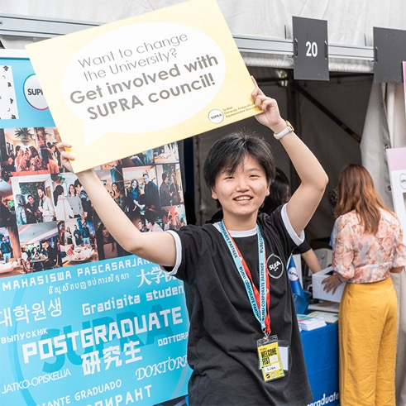

Co-Presidents

Minran Liu and Xinheng Wu

Xinheng Wu
I am a Master of Philosophy student studying Computer Science. I was elected as SUPRA Co-President from the 1 July 2020. Before that, I was a SUPRA general councillor and served as Co-Secretary. I appreciate the memorable and meaningful experience of representing, advocating, and working for our peer students as they have been an indispensable part of my journey at Usyd.

Minran Liu
I am presently a PhD candidate at the Department of Government and International Relations (IR) at Usyd. Before the role of the Co-President of SUPRA, I was a SUPRA general councillor and served as the Co-Education officer. Being a student representative is one of the most exciting and memorable things in my life.

Advocacy under COVID
SUPRA began to closely monitor the situation of COVID-19 before semester 1, 2020 began. We made four official submissions to the Vice-Chancellor detailing the support our fellow students needed during COVID-19. We were also the pioneers fighting for a fee reduction for online classes by conveying the clear message to the University that online tuition fees should not equal those of face-to-face courses. We have also advocated for our HDR students by requesting that the University provide a financial package to support all HDR students during COVID. Thanks to everyone's hard work, the University introduced the financial supports of: a general bursary, a hardship fund, a rebate of tuition fees and an HDR scholarship.
We were also closely monitoring the quality of online learning and HDR research support right from the beginning of COVID. Based on SUPRA's data from our caseworkers and peer assistant services regarding online teaching quality, we urged the University to ensure proper support for teachers delivering online teaching. We also communicated with some course coordinators directly. Thanks to everyone's effort, the overall quality of online teaching was greatly improved. We also pushed hard for extensions for all the students who required more time to do their work during COVID and urged the University to offer grant extensions for HDR students. By the end of 2020, all HDR students had been given an extension for one research period. Additionally, SUPRA distributed thousands of masks and hand sanitiser to our fellow students during COVID. We also worked closely with the University to help our students return to campus.

Online community engagement
In semester 2, 2020, students could only study from home (or even offshore) with limited access to support services, which caused significant difficulties in transition and learning. To best support our fellow students, SUPRA council and staff had many meetings to discuss supporting students' transitions and enriching student life online. From June to December 2020, a series of digital resources were delivered to thousands of postgraduate students. These resources were developed to help our fellow students in career development, understanding academic integrity, and credit recognition. In August, we organised two online orientation inductions – one for new international students and one for HDR students. 250 students attended and gave very positive feedback. Additionally, a postgrad student exclusive career discovery workshop was delivered to 200 participants in September, and we also shared the recording to the broader student communities. SUPRA also held an anti-racism workshop and mental health wellbeing workshop to promote a safer environment. We also ran various creative online social events, including one online dancing course, several online yoga classes, and virtual meet-up and chatting activities. Later in the year, fitness classes, free lunch, and hiking events were all resumed.

SUPRA membership and growth
In Semester 1 Welcome Week, we orientated 2000 new postgrad students on campus by distributing SUPRA welcome packs, hosting the welcome party, and having SUPRA representatives present at various University and faculty inductions. The campus closure made developing new memberships extremely difficult as we lost the chance to meet students face-to-face. Nevertheless, thanks to the countless efforts made by our staff members, as well as representation work, workshops and online activities by our fellow councillors and volunteers, we still achieved an increase of 4400 subscriptions (88%) on the SUPRA WeChat public account, and a 150% increase in followers on SUPRA’s Instagram throughout the whole year.

Thank you
We want to extend our sincere gratitude to each of the SUPRA staff, councillors, executive members, equity officers, committee members, and volunteers responsible for different issues. Without you these achievements would not have been possible.

Co-Vice Presidents

Yuhang Xia and Xiner Yuan

Yuhang Xia
I have been the Co-Vice President of SUPRA since 1 July 2020, as well as a postgraduate student of Master of Information Technology Management. I was the International Representative, and my main job in SUPRA has been leading the community committee to provide support to postgraduates.
2020 was a year full of challenges, difficulties, and hopes. In 2020, the world was threatened by the pandemic of COVID-19 with economies declining dramatically globally, countries closing borders, and our University closing doors. Thousands of Chinese international students were closed out of their beloved Uni, and physical courses were replaced by online ones. However, SUPRA has always been here to support the students.
In 2020, most in-person activities were cancelled due to the pandemic. However, we managed to bring more relief and courage to the University by holding SUPRA Roast event. We were also able to hold our first Hiking event of 2020 in semester 2, which I helped organise and advertise.
In October, I helped organise and advertise two SUPRA Roast events. We also held another Hiking event and Free Lunch – for which I accepted an interview with a reporter.
In November, I made an activity schedule for the next semester, and held a Free Lunch event with volunteers. For this event, I organised the venue, food, and volunteers.
Despite the hardships in 2020, I am lucky and proud to be with SUPRA. I helped and built connections with postgraduates in need and made their lives easier to some extent. SUPRA gives me a platform to provide help and support for others. I will always stand with SUPRA.
I hope that SUPRA can always support and care about their students. SUPRA helps us grow.

Xiner Yuan
I am a Master of Crosscultural and Applied Linguistics student and have been SUPRA Co-Vice President from 1 July 2020. Prior to that I was Co-Education Officer of SUPRA and still have ongoing passion for building SUPRA student community and developing the SUPRA volunteer network.
2020 has been very special. SUPRA created our first ever virtual orientation sessions in this trying time. We welcomed over 200 new students on WeChat, 90 international postgrads on International meet up, 50 HDR students on HDR Survival tips, and we are seeing hundreds of new followers on our social media platforms. Great thanks to all the devoted councillors, volunteers and staff, who created the content and worked behind the scenes for the welcome video, the induction sessions, our ‘Welcome to SUPRA’ page; took shifts on welcome stalls and online Q&A platforms, and other activities to make this festival come true. Thanks also to all University, faculty, and other student organisations for inviting, co-promoting SUPRA’s events, for their care about the student community, and their support of SUPRA to help us deliver the best student experience. SUPRA celebrated our 50th anniversary with resilience and growth. In the future, I hope to see council, volunteers and staff continuing working together to achieve their goals!

Co-Secretaries

Zhuoyuan Xie & Shiyu Bao (Eolande)
It was not easy to start a year like 2020. The pandemic swiftly changed SUPRA’s operations and the ways we engaged with students. However, this hasn’t been an impediment for us to ensure the transparency of decision-making and governance, as well as the engagement with our community.

Volunteer recruiting and training
As a student organisation, SUPRA is responsible for keeping a strong connection with our community, hence we implemented a brand new system with the Women’s Officer last year, which is used to maintain our close relationship with them. In total, around 100 postgrads joined us to work and serve our community; we were enlightened and encouraged by their passion and ambition. Together, we make our community a better one.
Training has always been an essential process for SUPRA to deliver our culture and service to our internal community. We prepared training sessions for our new councillors, new committee members, and volunteers to help them understand SUPRA and the student services SUPRA provides.

Meeting records and personnel management
We organised council meetings on a monthly basis, as well regular subcommittee meetings. The ratified meeting minutes and council roster have been well-maintained and made public on the SUPRA website.
In addition to this, in 2020, a new practice was added to our routine after entirely moving online – weekly executive Zoom meetings. We called executive meetings every Monday evening to keep each other updated and ensure that all the office bearers were on the same page. We have kept precise executive meeting records to ensure transparency.

Support and represent students
During Semester 2, 2020, many complaints were brought to our attention regarding the reassessment decision of the FINC6001 mid-semester online exam. Collaborating with the SUPRA Education Officer, we quickly reacted by collecting assessment information and students’ feedback, consulting with caseworkers, and then informing the Business School of students’ concerns. The Business School kindly reassessed the decisions and provide options for students to choose from.

Mental health, anti-racism, and equity training
To better support students during such an unprecedented time, we organised workshops to discuss topics that students cared about. At the beginning of the year, we held few Anti-Racism Morning Tea Sessions, inviting caseworker Francine as a speaker, to train SUPRA councillors to help and respond to peers regarding discrimination appropriately. We collaborated with the University’s Safer Communities Advisory Group in order to bring more workshops for our postgrad students. We also invited caseworkers Rill and Rebecca to deliver training sessions on equity groups to SUPRA councillors to increase our awareness of various communities. Together with the SUPRA Women’s Officer, we invited Dr. Lexine to deliver a Managing Anxiety and Stress workshop for students’ mental health.

Career help
Career help has been part of SUPRA Council’s service agenda since 2019. Because of COVID, we knew that an in-person career event would not be possible, so we moved to online career and recruiting information, to keep our students updated with the latest job information. There were 12 articles posted online in the past year, including nearly 50 companies’ recruitment information. One of the pieces is a forum designed for students who will graduate from universities in Australia.

Welcome Week
We coordinated the Welcome Week and Welcome Party in February 2020. With many SUPRA staff, councillors, committee members, and volunteers, we prepared and distributed more than 2000 packs, including SUPRA promotional flyers and 50th-anniversary merchandise. We also arranged various faculty-wide and university-wide inductions with the International Officers, and we cooperated with Women’s Officers to hold a successful and creative Welcome Party, serving nearly 100 postgraduates.

COVID-19
We formed an emergency team to provide our students with advice on enrolment, academic support, and financial support. We initiated a survey to investigate students’ concerns about remote learning in early February. With other SUPRA executive officers’ help, we consulted on the financial losses suffered by international students due to COVID-19. SUPRA representatives then argued the importance of financial support to the Vice-Chancellor at the February Academic Board meeting. After repeated negotiations, the University eventually released a detailed financial support plan to support students, including financial assistance for students affected by the travel ban and the tuition fee rebate.
2020 has been the most unexpected and challenging year ever. As the
Co-Secretaries of SUPRA, we have been dedicated to doing our best to serve the SUPRA Council and our community, to maintain the bond within Council and with postgrad students.
We are glad to see that our community has been growing even after all these surreal experiences we have all been through. We are honoured to have worked with the whole executive team, Council, and our members and volunteers. It would have been impossible to achieve any of these goals with any one of them missing.
We hope you have all enjoyed our journey together and with the relentless spirit that we have carried to a brighter future. See you all then.

Treasurer

Xuning Feng

My name is Xuning Feng, majoring in Master of Engineering (risk management). As the treasurer of SUPRA, I mainly deal with the financial management for the council and organisation of events.
Thanks for this amazing year, we made great achievements.

Anti-pandemic reaction
In 2020, COVID-19 impacted both daily lives and academic performance of postgraduate students in Usyd. As former International Officer and present Treasurer, I organised several events to distribute masks to students, reminding students to stay safe. In addition, I engaged in the organisation of online events, such as ‘Challenge me’ game on Instagram, which was set up to entertain and keep students in the social loop during the period of online learning.

Financial management
In 2020, the University cut part of our funding due to the pandemic. SUPRA literally went through a year without enough budget. Given this situation, the Co-Presidents and I came up with a solution: to cancel some on-campus activities (Basketball Tournament and Wine & Cheese). Despite the social fun we lost, we did keep our expenditure within the budget.

Teacher and Supervisor of the Year Awards
Because of the pandemic, we were not able to organise our usual in-person events on campus. At first, we wondered
whether we should hold the event this year. After several meetings, we decided that we should still hold the event on campus with limited numbers of participants and strict social distancing rules. In the end, around 30 supervisors and 5 teachers were selected as winners by postgraduate students. This event is an annual tradition at SUPRA and we were happy to find a way for it to continue safely.
I would like to send my appreciation to every councillor, committee member, and staff who supported SUPRA and our events in this special year. As I will graduate in a few months, I cannot stay in SUPRA and continue to do this kind of work. I hope that SUPRA can still play this indispensable role in Usyd and support more postgraduates in the future.

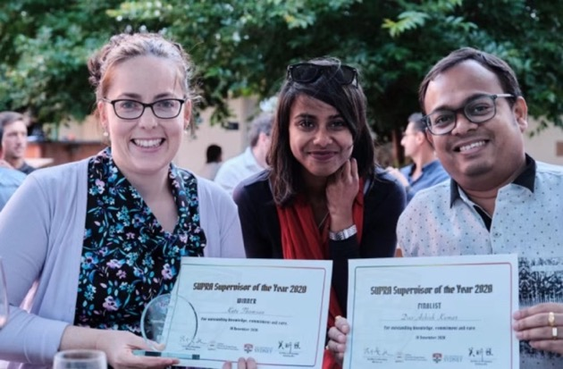

Co-Education Officers
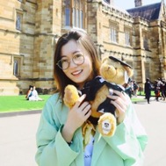

Di Wang and Ziyao Ding (Zoey)

Di Wang
I am a PhD student of Astronomy from the Faculty of Science. I became SUPRA Co-Education Officer from 1 July 2020. I was a member of the SUPRA Education Committee and always wanted to contribute to postgraduate students' life and study connection with University as a representative.

Ziyao Ding (Zoey)
I am an international student studying Master of Commerce coursework and have been a SUPRA Co-Education Officer since July 2020. Prior to that, I was an Education Committee member. With great enthusiasm, I always participated in student representation work to consult and reflect opinions from postgraduate students towards a better learning experience for students, especially under pandemic circumstances.

SUPRA Semester 1 2020 online learning experience survey and report submission to the University
Under the COVID-19 circumstances, from 23 March 2020, learning and assessments were moved online. To consult with students about their learning experiences and to continuously support postgraduates’ wellbeing, we conducted the Online Learning Experience Survey. This provided postgraduate students with an opportunity to give detailed feedback. The survey ran for two weeks and we received 178 responses from students across 8 faculties. A summary report, including concerns raised by students and recommendations, was presented to the University Executive Education Committee to assist the University’s planning and delivery of student learning and assessment in the following online semesters.

Social media outreach
SUPRA's multilingual online Q&A platforms, including SUPRA WeChat Assistant, Facebook, and Instagram served as interactive channels to answer, collect, and report postgraduate students’ everyday enquiries. Questions ranged from enrolment, scholarships, change of units, academic appeals, complaints and tenancy issues, to the events and activities held by SUPRA. Students were able to get peer advice on simple issues, and referrals to the right places for help with complex situations, such as SUPRA caseworkers. Over 1700 enquiries have been answered by these online Q&A platforms in the past year. We collected the problems students had when applying for the COVID-19 travel ban hardship financial assistance and the online study stipend and raised those issues at the first meeting of Student Consultative Committee (SCC) in Semester 1, 2020.

SUPRA survey and report about the University 12-week teaching semester proposal
After the University announced the proposal to change the teaching calendar to 12 weeks per semester, we quickly started our online survey of all postgraduate students, consulting their opinions on the proposal. Following that, to promote the interest of postgraduate students and make their voices heard, we participated in discussion with the University Committee and the University Semester Advisory Group, presenting postgraduate students’ concerns. Eventually, in mid-September 2020, we were glad to see that the final decision about the 2021 academic calendar made by the Academic Board reflected students’ opinions.
Under these extraordinary pandemic circumstances, in 2020 we all went through a tough year. We have done our best to consult students and reflect their voices. All of this could not have been done without support from the volunteer team, staff and council. It was a great honour to work with such a supportive team. We were most grateful for all the work from all our team members. We hope to continuously support each other and provide great student representation and advocacy to our postgraduate students and to make the postgraduate community great. All the best to SUPRA.

Director of Student Publications

Qinghan Zhang
I am studying Master of Media Practice and have been SUPRA Director of Student Publications since1 July 2020. Before that, I was a general councillor at SUPRA and I still have a keen interest in international student representation.
In 2020, SUPRA stood together to support postgrads in the face of the COVID-19 pandemic. I had the pleasure to become Director of Student Publications for 2020-2021. I was honoured to join the SUPRA team. During this period, with the great efforts of my predecessors (Huan Zheng and Hua Li) and other volunteers, our social media has been greatly improved, and our publicity methods have become much more diverse. We assisted in the promotion of various activities and established connections with postgraduates through our social media.

Social media
In 2020, we had great success building our online community. The Publications Committee operated SUPRA’s official social media channels (WeChat Publication Account, Instagram, Facebook, TikTok, and Weibo) to attract more postgrads to SUPRA’s social platforms and broaden the promotion of SUPRA events and information. The number of Facebook followers reached 4385, the number of followers on Instagram was more than 1200, we doubled our Weibo followers from the previous year, and the number of followers on the WeChat official account increased about 2000, to 9438 on 25 March 2021.

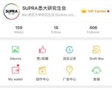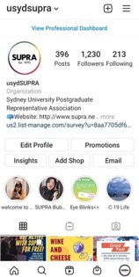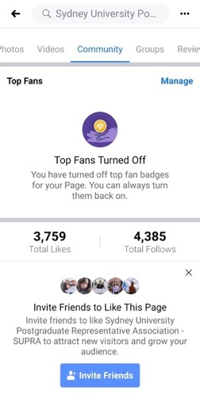
Instagram
Weibo
Facebook

Student engagement
We have been providing students with all kinds of university information, notices, Grad Post, original articles from SUPRA committees, as well as promoting SUPRA online events and in-person events. We have also established good communication and connections with other student organisations, such as USU, CIC and SUCSA. In the latter half of the year, when students could return to campus, we took and edited photos and videos for our in-person events again, and created social media posts to review events.

Designed promotional content and materials such as posters:

SUPRA Free Lunch
SUPRA Roast

Took and edited photos for events:
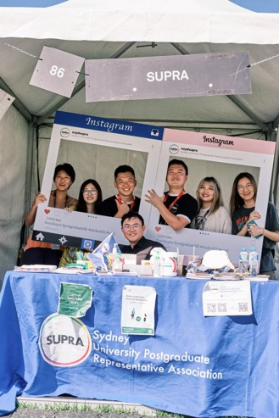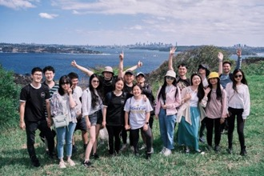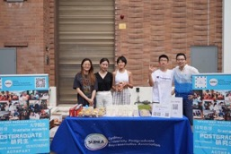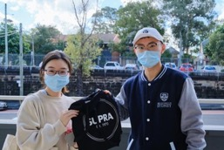
SUPRA Stay with You
Free Fitness Class
Free Lunch
2021 S1 Welcome Week
Hiking

Original content

We created original content for our social media platforms. The Publications team shot a series of original videos, including the ‘Introduction to SUPRA’ video, some event summary videos, and vlogs. Our WeChat official account continues to publish some original articles, such as the ‘Letter’, students interviews and Weekly News. We added weekly news summaries on Instagram and Facebook, we organised online activities such as Instagram special effects. We also designed some special promotional materials, such as Mid-Autumn Festival postcards.

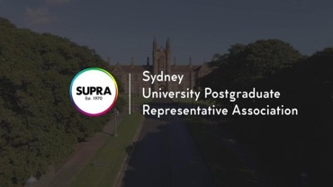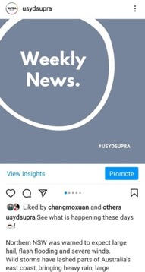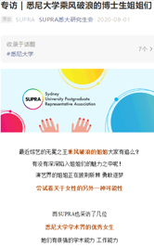
SUPRA Welcome Induction video
Weekly News: Original article about interviewing female PhD students

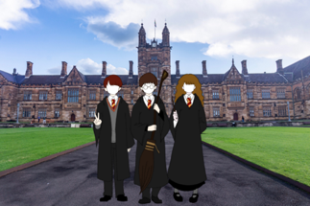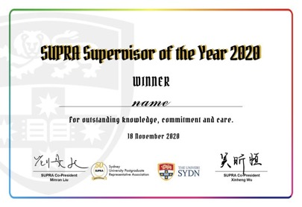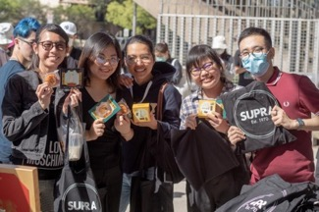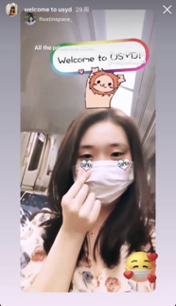
Instagram special effects
Original article about graduation photos
Mid-Autumn Festival Postcards
Certificate for Teacher/Supervisor of the Year 2020
Happy Lunar New Year

Thank you to our volunteers, staff, council, and constituents so much for helping me to contribute to a better Publications Committee during this hard year. I look forward to a better 2021 and hope our SUPRA team will be better and better.

Queer Officer

Position vacant

Aboriginal and Torres Strait Islander Officer

Position vacant

Co-Women’s Officers

Junying Chen (Cathy) and Ruge Zhao (Maruge)

As Women’s Officers, Junying (Cathy) Chen and Ruge (Maruge) Zhao have aimed to get closer to and help women around the campus since semester 2, 2020. We worked closely with SUSF, SUPRA staff and other communities to understand and meet different needs of women. 2020 was quite a challenging year, but we also did lots of online events to reach out to women students.

Online mental health workshop (Semester 2 2020)
Due to COVID-19, students had to stay at home and couldn’t meet friends for a long time. Under this situation, students are more likely to feel stressed with heavy study. To help students to identify and understand various mental health problems, we invited Dr Lexine Stapinski from The Matilda Centre to the workshop. She introduced the early warning signs of stress and also effective strategies for managing and reducing anxiety and stress.

Free fitness classes (Semester 2 2020)
To care for both the mental health and physical health of women, we introduced online yoga sessions for women students who needed to stay at home due to COVID-19. 32 students attended the online yoga sessions and gave feedback that these sessions helped to release their stress. Furthermore, we also worked with other councilors to develop climbing classes and also body balance classes, which more than 291 female students attended. In the next semester, we will develop more specific events for caring for both emotional and physical life of women around the campus.
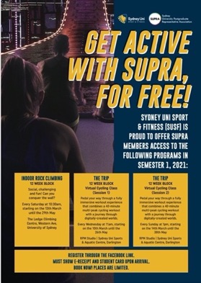
Safer committee working group
We have worked closely with the University, trying our best to represent women and ensure the women’s community voices can be heard. Being a member of the Safer Communities Working Group, we reviewed the University of Sydney ‘Student Sexual Misconduct Policy and Procedures’. We also planned an anti-racism workshop with cooperation from the University. Meanwhile, we also advocated bigger parking spaces for parent students who have to bring their children to campus.

Working with and for you
We are proud to have worked alongside other councillors, participating and leading events such as Supervisor and Teacher of the Year Awards, Stay with You and Welcome Week event.

Co-International Officers
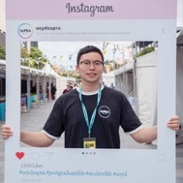

Zheng Li and Shuyun Zhu

International Officers are committed to promote and advocate for the best interests of international students from various backgrounds. Due to the pandemic, many of our traditional in-person events, including Wine & Cheese and basketball tournaments had to be suspended. Nevertheless, we have been committed to protecting the rights and interests of international students in numerous ways, as well as maintaining their physical and mental health during this challenging time.

Student representation
As the International Officers, we were selected to be SUPRA student representatives attending various University meetings regularly, like the University Executive Student Consultative Committee and the Academic Quality Committee. We shared many perspectives from students during these meetings and were involved in a lot of decision-making at the school level. Overall, that was a unique experience.

SUPRA International Student Welcome Session
In August 2020, we conducted the SUPRA Online International Student Welcome Sessions. Because of the pandemic, many international students could not travel to the Sydney, and had to study online. As the International Officers, we provided this opportunity for them to understand the University’s online resources and what kind of services SUPRA could offer. And we also edited the SUPRA introduction video with the Director of Student Publications to explain SUPRA to all students.

Pre-arrival Session in China
In January 2020, as SUPRA’s representatives, we attended Pre-arrival Session of Sydney University in Shenzhen, China. The session had over 100 attendees including new students and their parents. We explained how SUPRA can help international students better adapt to new campus life and offer assistance. It was a good opportunity to build connections with new students and help them understand what SUPRA can offer.

Reaction to COVID-19 outbreak
Many students were affected by the outbreak of coronavirus in early 2020. Particularly, international students were affected by the travel ban. To support students during this time we undertook the following activities: to apply for support from the University, we collected feedback from the students who were in need of help; we kept students updated about Australian government and Sydney University policies on our social media platforms; and we organised online events on Instagram and WeChat to encourage people to stay at home.

Hiking
The hiking activities which were held on a regular basis had been suspended for nearly a year due to the pandemic. We successfully organised one hiking event in March 2021 after the strict COVID safety rules were loosened. Over 30 international students participated in the Manly beach walk. They not only used this opportunity to explore the magnificent scenery of Manly, but also made new friends and maintained physical and mental health.

Final words
It was really an unforgettable journey working with so many excellent friends and sharing the same goals. And it has also been an honor to work in SUPRA fighting for the rights of international students. We promise we tried our best to fulfill our responsibilities as the International Officer and wish SUPRA all the best in the following years under the lead of the new councillors.

Satellite Campus Officer

Sihan Liu

I am studying Master of Management (CEMS) and have been a SUPRA Satellite Campus Officer from 1 July 2020. Prior to that I was actively attending Usyd’s on-campus activities and had a strong interest in being a student representative.
2020 has changed the way that people lived, but SUPRA has responded to these changes to make sure we are still supporting students. Online studying didn’t push us to cut down our activities, instead we have been doing more things to ensure students can engage in campus life, and to help make sure that they don’t regret studying online – especially for those students who have few connections to main campus.
SUPRA has had great success in engaging satellite campus students. We have done this by publishing an introduction article, working with CEMS Club to run SUPRA Roast (Talk Show), and also having group activities and dining events. More satellite campus students have joined SUPRA as they believe that this is a way they can be involved in campus life as much as possible.
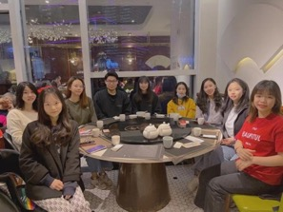
Guangzhou Dinner Event, March 2021
It has been my honour to work with SUPRA staff, officers and councillors, ensuring students have had the best chance to get to know other students in the same city, and sharing our experiences of working for students during the pandemic.
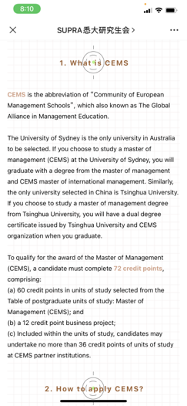
Article: CEMS, January 2021
Our publication was read by over 500 students, and many satellite campus students showed their willingness to participate in main campus activities in order to broaden their networks and to have wonderful after-school activities.
I am so proud to be part of such an energetic team who always stands up to speak for Sydney University postgraduates. I am looking forward to a better 2021 and hope there will be more opportunities to utilise my organisational skills in the future.
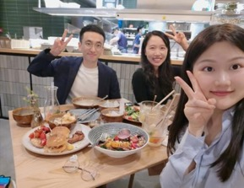
Shenzhen Dinner Event, March 2021

Disabilities Officer

Marguerite Biasatti (1 January 2020 – 30 June 2020)
Position vacant (1 July 2020 – 31 December 2020)

Staff reports

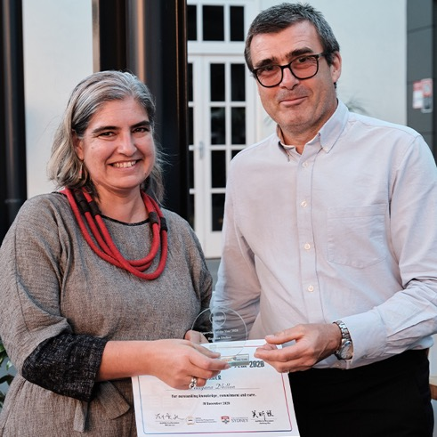

Postgraduate Advocacy Service

Postgraduate Advocacy and Policy Officers: Rillark Bolton, Allison L’Armour, Heather Mabry, Rebekah Hatfield
Coordinators: Hank Whan and Francine Seeto
In 2020, SUPRA’s 50th anniversary, we changed our name from Student Advice and Advocacy Service to Postgraduate Advocacy Service – to emphasise our professional status and target group. In general discussion we are now known as SUPRA caseworkers or the SUPRA casework service.
In March COVID-19 shut down main campus and like the rest of the University, SUPRA commenced working from home. We successfully transitioned to delivery of casework by Zoom, telephone and email, and recorded our highest total yet of new cases – 1343 for the year, which was an 18% increase from 2019. For the first time tenancy topped the list of case presentations, followed by academic honesty and appeals, which reflected the unsettling year for postgrads. Most cases were international students who were impacted by need to return home, lost jobs, or the unfamiliarity of online exams.
Our COVID-safe withdrawal of face-to-face appointments meant it was imperative for us to keep our website materials as up-to-date as possible. We reviewed, updated, and wrote new Get Help and HDR articles so that students could access timely information to support them during this time.
The casework service contributed significantly to the research and production of SUPRA’s 50th anniversary video, which involved interviews with past SUPRA presidents and councillors. The video is now showcased on the SUPRA 50th anniversary page on the website. One of our caseworkers Rebekah Hatfield shot and was main editor of the video. Caseworkers also featured in a new council-produced ‘Introduction to SUPRA’ video for the purpose of faculty inductions.
The casework service coordinators Hank Whan and Francine Seeto assisted the SUPRA Co-Presidents and Co-Education Officers across several systemic issues. These included: advocacy to the University on behalf of international and HDR students for emergency financial assistance; reduction in tuition fees; and flexible assessment and special consideration policies. We also supported the SUPRA Co-President and Co-Vice President in meeting with the Senior Policy Advisor to the NSW Minister for Higher Education to lobby for improvements to the NSW government’s assistance package for international students.
Even with a pandemic we managed to support SUPRA council in holding another successful SUPRA Supervisor of the Year awards night. Held in the Courtyard Restaurant, COVID restrictions capped attendance at the awards night at 100. Winning supervisors stood out for their exceptional care for students’ wellbeing in an extraordinary year.
Revision of HDR policies was front and centre last year. In 2020 we advocated, as a casework service and in collaboration with SUPRA student representatives, on University committees for improvements to the supervision, progression and planning, and examination policies and procedures.
The casework service led SUPRA’s submission to the 2020 Review of the Disability Standards for Education 2005.
During 2020 the casework service bid farewell to Rebekah Hatfield who moved to sunny Griffith University. Thanks and good luck, Bek.

SUPRA Legal Service
Solicitors/Registered Migration Agents: Ingrid van Tongeren, Sue-Ellen Hills
Legal Assistants: Zekun (Eilleen) Yang, Ziwei (Sophia) Zhang

From the start of 2020, SUPRA’s 50th anniversary year, the Legal Service saw an increase in demand for advice from students. In March 2020, in the face of the COVID-19 pandemic, the Legal Service, along with the rest of SUPRA and the University, transitioned to working from home. Despite the sudden change in mode of service delivery, we successfully transitioned to service delivery by Zoom and telephone.
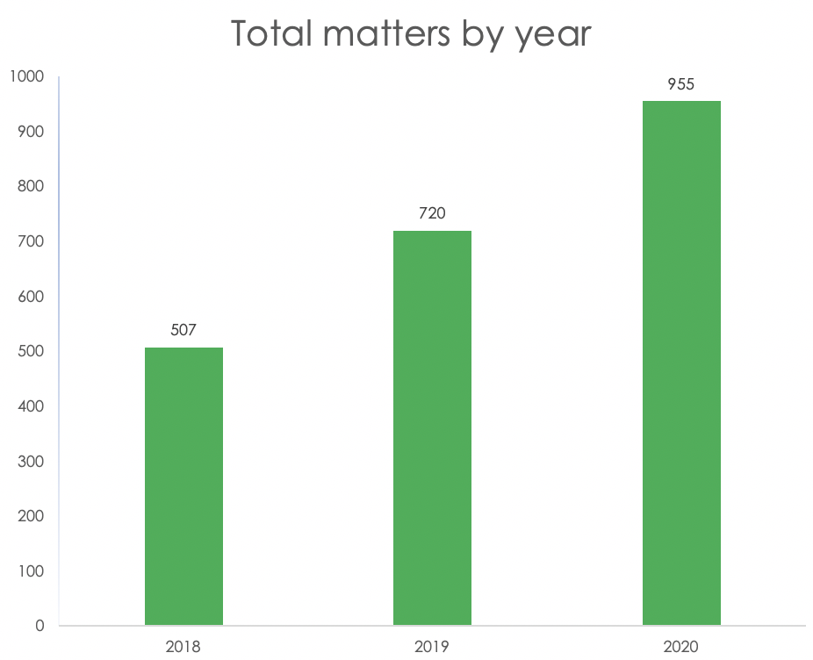
The annual increase in demand continued despite the challenges and saw us record our highest number of new cases yet. In 2020 we handled 955 matters which was a 33% increase from 2019 (see Figure 1).
Figure 1
The highest demand was seen in migration, followed by employment, and credit and debt/consumer matters (see Figure 2). We also saw a large increase in the number of family law and family-violence related matters. These matter types reflected the direct impact of the pandemic on postgrads, as well as uncertainty stemming from the numerous quickly implemented legislative and policy changes in response to the effects of the pandemic. Whilst all other matter types accounted for less percentage wise, in raw numbers demand remained consistent with past years in most of the remaining matter types. We also provided legal casework services to student associations where the majority of the members are postgrads in a number of separate legal matters.
During 2020 we reviewed and updated 29 ‘Get Help’ articles (19 in English, 10 in Simplified Chinese) and 20% of the HDR Guide content on the SUPRA website. We also wrote, and frequently updated, new ‘Get Help’ articles about COVID-related changes to legal areas, such as migration and tenancy. To keep students informed, we also contributed to eGrad (now Grad Post) and WeChat. The Legal Service also contributed to SUPRA’s 50th anniversary video and to the council-produced ‘Introduction to SUPRA’ video for use at inductions.
Despite the pandemic we continued our Council support role by maintaining our provision of legal services to councillors and Equity Officers – including through the provision of information and advice, as well as contract and other document drafting.
In conjunction with the SUPRA casework service, we contributed to the advocacy for the revision of HDR policies in order to obtain improvements in key areas. We also contributed to SUPRA’s submission to the ‘2020 Review of the Disability Standards for Education 2005’.
During 2020 we bid farewell to our legal assistants Eilleen and Sophia who both finished their law degrees and Practical Legal Training courses, and successfully found employment. Congratulations to you both. Eilleen continues to assist us with translation work as needed.
Despite the challenges of 2020, the Legal Service successfully managed to provide uninterrupted legal services to an increasing number of postgrads. A huge thank you must go to everyone in the team for another year of outstanding work.
Report by Ingrid van Tongeren

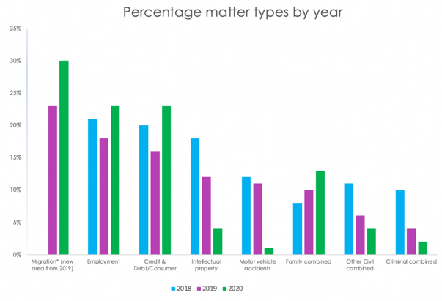

Figure 2

Administration and Publications
Operations Manager: Louise Corney
Data Entry Officer: Justine Wilcox
Administration and Publications Officers: Rachel Engdahl, Anthea Fitzgerald and
Emma Davidson

Justine, Anthea, Rachel and Emma are the first point of contact for the SUPRA community, providing another year of professional and trauma-informed assistance to postgraduates at the University. The work they perform is central to the function of the organisation – both at reception and as the people who support formal communications to our members. Our administration workload continues to grow, and the efficiency with which it is handled is a testament to the work ethic of the Administration and Publications (AP) team.
Louise continued in her role as Operations Manager. In the role she coordinates the Admin and Publications team, and works with staff and council on a broad range of matters including administration, funding applications, policy, training and human resources.
In 2020, the AP team supported the Legal Service and Postgraduate Advocacy Service with intake for a combined total of 2298 new casefiles and legal matters. This figure is a substantial increase on previous years and only represents one element of the student-facing work performed by the team. Students who approached the service via email, our website or by phone had a personal interaction with SUPRA’s AP Team and were met with empathy and professionalism as they were referred to a caseworker or solicitor.

Publications
SUPRA continues to grow our online presence. We have aligned content and styles between our website and newsletter Grad Post (formerly eGrad), building on aesthetic appeal and accessibility.
COVID-19 led to rapid changes across SUPRA and the University, and throughout 2020 we updated the content on our website continuously to ensure students were informed about changes and knew where and how to access help.
We conducted a survey of our members about our website with very encouraging results. Of the 91 respondents 91.51% found information on our website to be somewhat or very trustworthy and 93.41% found the information somewhat easy or very easy to find.
Grad Post is an important source of up to date information about matters impacting students, including events, University changes, legal information and SUPRA election information. In March we moved from a fortnightly to weekly publication as COVID-19 changes and updates necessitated time-sensitive communication with our members. Throughout 2020 we sent 54 editions of Grad Post. Of these, 8 were special editions that covered time-sensitive topics and announcements such as the HDR survey about financial hardship, 12-week teaching semesters, and changes to our service provision.

Elections
SUPRA’s General Election was held online for the first time in 2020 with great success and over 1200 votes cast. Rafael Mazzoldi was the Returning Officer and provided SUPRA with a report regarding the implementation of 2020’s online election and recommendations for future processes, which have been incorporated into ongoing policy updates.

Policy development
Our Policy Manual is being updated by Ingrid van Tongeren. A new Constitution was presented at the 2020 AGM for discussion and voting. The updated manual includes changes to the Constitution, voting processes and SUPRA’s Code of Conduct. The new manual provides clearer guidance and expectations of SUPRA’s elected representatives.

Moving forward
As we move into the next phases of living with the COVID-19 pandemic, SUPRA’s AP team will remain a reliable source of information and support for the postgraduate community. Our provision of resources and support continues to adapt to meet the changing needs of students, on and off campus.
We look forward to continuing to work alongside our members, colleagues and councillors to ensure postgraduate students have the representation and support that they deserve and an educational experience that will endure beyond their time at the University.

Financial report

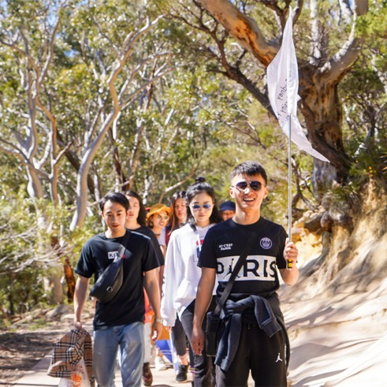

SYDNEY UNIVERSITY POSTGRADUATE
REPRESENTATIVE ASSOCIATION
(SUPRA)
FINANCIAL REPORT
FOR THE YEAR ENDED 31 DECEMBER 2020

SYDNEY UNIVERSITY POSTGRADUATE REPRESENTATIVE ASSOCIATION

(SUPRA)
31 DECEMBER 2020
CONTENTS
Page No.
Auditor's Independence Declaration 1
Statement of Comprehensive Income 2
Statement of Financial Position 3
Statement of Changes in Equity 4
Statement of Cash Flows 5
Notes to the Accounts 6-13
Statement by the SUPRA Council 14
Independent Auditor's Report 15-18
Detailed Statement of Comprehensive Income 19-22

C M PITT & CO

Chartered Accountants
Page 1
DECLARATION OF INDEPENDENCE BY CM PITT & CO TO THE COUNCILLORS OF THE
SYDNEY UNIVERSITY POSTGRADUATE REPRESENTATIVE ASSOCIATION (SUPRA)
As lead auditor for the audit of Sydney University Postgraduate Representative Association (SUPRA) for the year ended 31 December 2020, I declare that, to the best of my knowledge and belief, there have been:
- No contraventions of the auditor independence requirements of the Corporations Act 2001 in relation to the audit; and
- No contraventions of any applicable code of professional conduct in relation to
the audit.
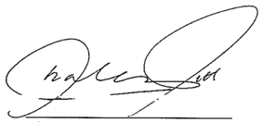
Charles M Pitt
C M Pitt & Co
Units 6 & 7, 2 Philip Street
STRATHFIELD NSW 2135
Dated: 12 May 2021

Liability limited by a scheme approved under Professional Standards Legislation

SYDNEY UNIVERSITY POSTGRADUATE REPRESENTATIVE ASSOCIATION
STATEMENT OF PROFIT OR LOSS AND OTHER COMPREHENSIVE INCOME
FOR THE YEAR ENDED 31 DECEMBER 2020
Page 2
 | Note | 2020  $ | 2019  $
Income
University Funding |  | 2,025,015 | 1,924,476
Interest received |  | 178 | 5,056
Sundry Income |  | 12,942 | 3,419
Total Income |  | 2,038,135 | 1,932,951
Expenses:-
Employment Expenditure | 5 | 1,604,339 | 1,462,016
Administration Expenditure |  | 232,625 | 183,541
Activities & Functions |  | 23,791 | 84,841
Publications |  | 11,149 | 12,611
Contestable funding |  | 105,904 | 132,870
Special projects |  | 63,688 | 60,359
Total expenses |  | 2,041,496 | 1,936,238
Surplus (deficit) for the year |  | (3,360) | (3,287)
Income tax expense |  | - | -
Deficit after income tax for the year |  | (3,360) | (3,287)
Other comprehensive income for the year |  |  | -
Cash Flow Boost |  | 100,000
Total surplus (deficit) for the year attributed to members of the Association |  | 96,640 | (3,287)

The Associating notes form part of these accounts.

SYDNEY UNIVERSITY POSTGRADUATE REPRESENTATIVE ASSOCIATION
STATEMENT OF FINANCIAL POSITION
AS AT 31 DECEMBER 2020
Page 3
 | Note | 2020  $ | 2019  $
ASSETS
Current assets
Cash & cash equivalents | 2 | 566,363 | 392,086
Trade & other receivables | 3 | 81,572 | 99,821
Total current assets |  | 647,935 | 491,906
TOTAL ASSETS |  | 647,935 | 491,906
LIABILITIES
Current liabilities
Trade & other payables | 4 | 208,260 | 258,469
Employee benefits | 6 | 99,003 | 71,256
Total current liabilities |  | 307,262 | 329,725
Non-current liabilities
Employee benefits | 6 | 316,842 | 234,991
Total non-current liabilities |  | 316,842 | 234,991
Total liabilities |  | 624,105 | 564,716
Net assets |  | 23,830 | (72,810)
EQUITY
Retained Earnings | 7 | 23,830 | (72,810)
Total equity |  | 23,830 | (72,810)

The Associating notes form part of these accounts.

SYDNEY UNIVERSITY POSTGRADUATE REPRESENTATIVE ASSOCIATION
STATEMENT OF CHANGES IN EQUITY
FOR THE YEAR ENDED 31 DECEMBER 2020
Page 4
 | Note | 2020  $ | 2019  $
RETAINED EARNINGS
Balance at the beginning of the year |  | (72,810) | (69,523)
Surplus / (deficit) attributed from operations |  | 96,640 | (3,287)
Balance at the end of the financial year | 7 | 23,830 | (72,810)

The Associating notes form part of these accounts.

SYDNEY UNIVERSITY POSTGRADUATE REPRESENTATIVE ASSOCIATION
STATEMENT OF CASH FLOWS
FOR THE YEAR ENDED 31 DECEMBER 2020
Page 5
 | Note | 2020  $ | 2019  $
CASH FLOWS FROM OPERATING ACTIVITIES
Cash receipts
University Funding |  | 2,159,934 | 1,927,895
Interest Received |  | 178 | 5,056
 |  | 2,160,113 | 1,932,951
Cash payments
Payments to suppliers and employees |  | (2,048,042) | (1,932,800)
 |  | (2,048,042) | (1,932,800)
Net cash provided by / (used in) operating activities | 9 | 112,071 | 151
CASH FLOWS FROM INVESTING ACTIVITIES
Purchase of Property, plant
and equipment |  | - | -
Net cash provided by/(used in) |  | - | -
investing activities
(Decrease)/ increase in cash held |  | 112,071 | 151
Cash and cash equivalents at the beginning of the year |  | 392,086 | 391,935
Cash and cash equivalents at the end of the year | 2 | 504,157 | 392,086

The Associating notes form part of these accounts.

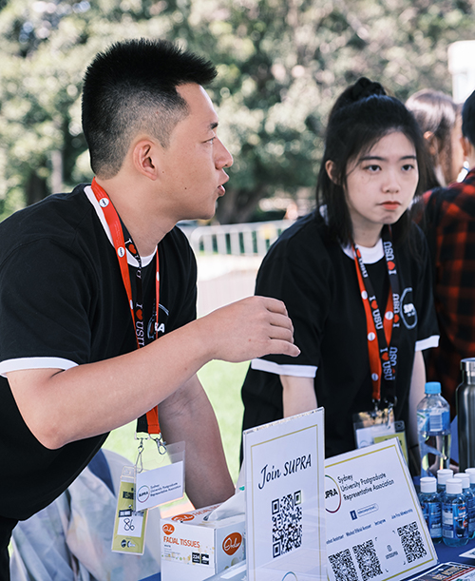
SUPRA 2021 Welcome Week stall

SYDNEY UNIVERSITY POSTGRADUATE REPRESENTATIVE ASSOCIATION
NOTES TO AND FORMING PART OF THE ACCOUNTS
FOR THE YEAR ENDED 31 DECEMBER 2020
Page 6

NOTE 1 STATEMENT OF SIGNIFICANT ACCOUNTING POLICIES
The financial statements are a general purpose financial report that have been prepared in accordance with Accounting Standards , Urgent Issues Group Interpretations and other authorities pronouncements of the Australian Accounting Standards Board. The financial report was authorised for issue by the Sydney University Postgraduate Representative Association (SUPRA) on 12 May 2021.
Compliance with Australian Accounting Standards - Reduced Disclosure Requirements
The financial statements of Sydney University Postgraduate Representative Association (SUPRA) comply with Australian Accounting Standards - Reduced Disclosure Requirements as issued by the Australian Accounting Standards Board (AASB).
They satisfy the requirements of SUPRA its constitution and the reporting requirements of SUPRA.
SUPRA is unincorporated and domiciled in Australia. The following is a summary of the material accounting policies adopted by SUPRA in the preparation of the financial report.
The accounting policies have been consistently applied unless otherwise stated. The financial report has been prepared on an accrual basis and is based on historical costs and does not take into account changing money values, or except where specifically stated current valuations of non current assets. Cost is based on the fair values of the consideration given in exchange for assets.
(a) Economic Dependence
The financial report is prepared on the basis that SUPRA is a going concern. SUPRA is dependent on the allocation of funds from the Student Services and Amenities Fee ( SSAF) by the University of Sydney. The University of Sydney provides SUPRA with premises, utilities and computers, in order to conduct its operations. No dollar value has been attributed to these services.
(b) Furniture, Plant and Equipment
Furniture, Plant and Equipment are measured on the cost basis less depreciation and impairment losses.
The carrying amount of furniture, plant and equipment is reviewed annually to ensure it is not in excess of the recoverable amount from these assets. The recoverable amount is assessed on the basis of the expected net cash flows that will be received from the assets employment and subsequent disposal.

SYDNEY UNIVERSITY POSTGRADUATE REPRESENTATIVE ASSOCIATION
NOTES TO AND FORMING PART OF THE ACCOUNTS
FOR THE YEAR ENDED 31 DECEMBER 2020
Page 7

CONTINUED
(c) Depreciation
Depreciation is calculated on a straight line basis so as to write off the net cost of each item of property, plant and equipment over its expected useful life. Estimates of remaining useful life are made on a regular basis for all assets, with annual reassessments for major items.
(d) Receivables
Other receivables represent the amount due at balance date.
(e) Amounts Payable
These amounts represent liabilities for goods and services provided to the consolidated entity prior to the end of the financial year, which are unpaid. The amounts are unsecured and are usually paid within thirty (30) days of negotiation.
(f) Maintenance and Repairs
Maintenance, repair costs and minor renewals are charged as expenses as incurred.
(g) Employee Benefits
(i) Wages, salaries and annual leave
Liabilities for wages, salaries and annual leave expected to be settled within 12 months of the reporting date are recognised in respect of employees' services up to the reporting date and are measured at the amounts expected to be paid when the liabilities are settled.
(ii) Long service leave
Employee benefits for long service leave payable no later than three years have been recognised with respect to the employee period to service and leave taken up to the reporting date and are measured at the amounts expected to be paid when the liabilities are settled. There have been no changes to the method used to calculate the liability.
(iii) Termination benefits
Termination benefits are payable when employment is terminated before the normal retirement date, or when an employee accepts voluntary redundancy in exchange for these benefits.

SYDNEY UNIVERSITY POSTGRADUATE REPRESENTATIVE ASSOCIATION
NOTES TO AND FORMING PART OF THE ACCOUNTS
FOR THE YEAR ENDED 31 DECEMBER 2020
Page 8

CONTINUED
SUPRA recognises a liability for the payment of termination to staff in accordance with Enterprise Agreement 2020. There has been no decision to terminate staff. The provision has been created with respect to uncertainty of continuing funding by Government of the Student and Administration Service Fee (SSAF). (refer note 1(a)). A decrease in funding would impact on the scale of services provided and the staff employed. The sum set aside is 30 % of the measured amount at the reporting date.
(iv) National Entitlement Security Trust ( NEST)
SUPRA have contributed to the National Entitlement Security Trust (NEST) towards future liability to pay employee benefits and the account is specific for this purpose.
(refer note 2 and 6)
(h) Leases
Operating lease payments are charged to expense in the period in which they occur.
(i) Cash
For purposes of the Statement of Cash Flows, cash includes deposits at call which are readily convertible to cash on hand and which are used in the cash management function on a day-to-day basis.
(j) Goods and Service Tax (GST)
All revenue is stated net of the amount of Goods and Service Tax (GST).
(k) Comparatives
Where necessary, comparative information has been reclassified to achieve consistency in disclosure with current financial year amounts and other disclosures.
(l) Critical Accounting Estimates and Judgments
SUPRA evaluates estimates and judgements incorporated into the financial report based on historical knowledge and best available current information. Estimates assume a reasonable expectation of future events and are based on current trends and economic data, obtained both externally and within the group.

SYDNEY UNIVERSITY POSTGRADUATE REPRESENTATIVE ASSOCIATION
NOTES TO AND FORMING PART OF THE ACCOUNTS
FOR THE YEAR ENDED 31 DECEMBER 2020
Page 9

CONTINUED
(m) Impairment
SUPRA assess impairment at each reporting date by evaluating conditions specific to the asset group that may lead to impairment of assets. Where an impairment trigger exists, the recoverable amount of the asset is determined. Value-in-use calculations performed in assessing recoverable amounts incorporate a number of key estimates.
No impairment has been recognised for the year ended 31 December 2020
(n) CHANGES IN ACCOUNTING POLICIES
The SUPRA has adopted all new and revised accounting standards and interpretations issued by the AASB that are relevant to its operations, and which became mandatory for the current financial reporting period. These accounting standards and interpretations did not have any significant impact on the financial performance or position of the SUPRA.
AASB 1058 Income of Not-for-Profit Entities (AASB 1058) and AASB 15 Revenue from Contracts with Customers (AASB 15)
AASB 1058 clarifies and simplifies the income recognition requirements that apply to not-for-profit (NFP) entities in conjunction with AASB 15. AASB 1058 and AASB 15 supersede all the income recognition requirements relating to private sector NFP entities, and the majority of income recognition requirements relating to public sector NFP entities, previously in AASB 1004 Contributions.
The SUPRA has adopted the both AASB 1058 and AASB 15 effective from 1 July 2019 using the modified retrospective method. No impact was noted on the timing and quantum of revenue previously reported from the adoption of AASB 1068 and AASB 15. Accordingly, the information presented for the year ended 31 December 2019 has not been restated.
AASB 15 is applicable to the revenues derived from government funding, donations, bequests year to which the revenue relates to. Sundry income is recognised on an accruals basis when derived, at the point at which performance obligations are satisfied. Interest and other investment income is recognised in accordance with AASB 9 and AASB 16 respectively.

SYDNEY UNIVERSITY POSTGRADUATE REPRESENTATIVE ASSOCIATION
NOTES TO AND FORMING PART OF THE ACCOUNTS
FOR THE YEAR ENDED 31 DECEMBER 2020
Page 10
CONTINUED
AASB 16 Leases (AASB 16)
AASB 16 introduces a single, on-balance lease sheet accounting model for lessees. A lessee recognises a right-of-use asset representing its right to use the underlying asset and a lease liability representing its obligation to make lease payments.
The SUPRA does not recognise right of use of the asset and for leases with low-value underlying assets.
The University of Sydney provide full office facilities to SUPRA at no cost.
Please refer note 1(a) economic dependence.
NOTE 2
 | 2020  $ | 2019  $
Cash & Cash Equivalents
Cash at Bank and on hand | 324,531 | 150,254
Deposit with NEST | 241,832 | 241,832
 | 566,363 | 392,086

NOTE 3
 | 2020  $ | 2019  $
Trade & Other Receivables
Receivables | 8,219 | 23,650
Prepayments | 3,155 | 2,935
SUPRA Legal | 70,198 | 73,236
 | 81,572 | 99,821

NOTE 4
 | 2020  $ | 2019  $
Trade & Other Payables
Sundry payables and accrued expenses | 110,693 | 107,310
Deferred revenue | 97,567 | 151,159
 | 208,260 | 258,469

SYDNEY UNIVERSITY POSTGRADUATE REPRESENTATIVE ASSOCIATION
NOTES TO AND FORMING PART OF THE ACCOUNTS
FOR THE YEAR ENDED 31 DECEMBER 2020
Page 11
CONTINUED
NOTE 5
 | 2020  $ | 2019  $
Employee Remuneration
Salaries & Stipends | 1,297,109 | 1,222,182
Superannuation | 149,641 | 126,039
Employee benefit provisions | 109,598 | 27,200
Payroll Management Systems | 7,018 | 6,567
Payroll Tax | 18,600 | 38,845
Staff Development and Training | 3,654 | 16,752
Staff Support & supervision | 6,709 | 8,266
Staff Travel, Meals & Accommodation | 1,079 | 3,388
Workers Compensation Insurance | 10,585 | 10,830
Staff Recruitment | - | 590
Sundries | 346 | 1,358
 | 1,604,339 | 1,462,016

NOTE 6
 | 2020  $ | 2019  $
Employee benefits liabilities
Current
Provision for Annual Leave | 99,003 | 71,256
Non Current
Provision for Long Service Leave | 82,219 | 59,484
Provision for Redundancy | 234,623 | 175,507
 | 316,842 | 234,991

At 31 December 2020 the total amount provided for a future liability was $415,845 Funds to extents of $241,832 (2019 - $241,832) are held on behalf of employees in the National Entitlement Security Trust (NEST).

NOTE 7
 | 2020  $ | 2019  $
Retained Funds
Retained Funds at the beginning of the year | (72,810) | (69,523)
Surplus/(Deficit) | 96,640 | (3,287)
Retained Funds at the end of the year | 23,830 | (72,810)

NOTE 8
 | 2020  $ | 2019  $
Auditors Remuneration
Audit of financial statements | 8,200 | 8,200
SYDNEY UNIVERSITY POSTGRADUATE REPRESENTATIVE ASSOCIATION
NOTES TO AND FORMING PART OF THE ACCOUNTS
FOR THE YEAR ENDED 31 DECEMBER 2020
Page 12
CONTINUED
NOTE 9
 |  | 2020  $ | 2019  $
Reconciliation of Net Cash Inflow
from Operating Activities to Surplus/(Deficit)
Net Cash Inflow/(Outflow) from operating activities |  | 112,071 | 151
Change in Operating Assets and Liabilities
Increase/(Decrease) in Other Current Assets |  | (18,249) | (36,848)
(Increase)/Decrease in Trade and other payables |  | 50,209 | 60,611
(Increase)/Decrease in Employee Benefits |  | (109,598) | (27,200)
Surplus/ (Deficit) for the year |  | 34,434 | (3,287)

NOTE 10 Financial Instruments

(a) Terms, Conditions & Accounting Policies
Accounts Receivable
Other small sundry sums are net of any provisions for amounts estimated to be uncollectable. Interest is not charged on outstanding amounts.
Accounts Payable
Liabilities are recognised for amounts to be paid in the future for goods or services received, whether or not billed to the University. Accounts payable are normally settled within thirty (30) days from date of invoice and no interest is incurred on these accounts.
(b) Credit Risk Exposures
The Association's maximum exposures to credit risk at balance date in respect of each class of financial asset is the carrying amount of those assets as indicated in the statement of financial position, net of any provision for doubtful debts. The Association does not have a significant exposure to any individual counterparty other than the short term money on deposit with a major commercial bank.

SYDNEY UNIVERSITY POSTGRADUATE REPRESENTATIVE ASSOCIATION
NOTES TO AND FORMING PART OF THE ACCOUNTS
FOR THE YEAR ENDED 31 DECEMBER 2020
Page 13
CONTINUED
(c) Net Fair Values
The net market values of the Association's short-term deposits,cash management accounts, accounts receivable, accounts payable and accrued charges approximate their carrying amounts. The aggregate net fair values of financial assets and financial liabilities at balance date are stated in the accounts.
NOTE 11 Lease
SUPRA have a lease agreement for a photocopier machine.
Minimum operating lease payments are as follows:
 | within 1 yr
31-Dec-20 | $21,700
Lease expenses during the financial year was $ 21,700 ( 2019 - $ 20,387)
NOTE 12 Events Subsequent to Balance Date
No transactions or events of a significant nature have occurred since balance date.
NOTE 13 Related Parties
Stipends are paid to office bearers and other counsellors in accordance with SUPRA's Stipend policy.
NOTE 14 Association Details
The office of University of Sydney Postgraduate Representative Association is situated
at Level 2, Holme Building (A09), The University of Sydney NSW 2006.
Permanent employees at year end were thirteen (13) (2019 - 13)
The Association's Australian Business Number (ABN) is: 17 011 530 375.

SYDNEY UNIVERSITY POSTGRADUATE REPRESENTATIVE ASSOCIATION
STATEMENT BY THE SUPRA COUNCIL
Page 14
In accordance with a resolution of the Council of the Sydney University Postgraduate Representative Association (SUPRA).

In our opinion:

- the Statement of Comprehensive Income is drawn up so as to give a true and fair view of the deficit of the Association of the year ended
31 December 2020;

- the Statement of Financial Position is drawn up so as to give a true and fair view of the state of affairs of the Association as at 31 December 2020;

- at the date of this Statement there are reasonable grounds to believe
that the Association will be able to pay its debts as and when they fall
due;

- as detailed in note 1 to the financial statements, the financial viability
of SUPRA is dependent on the allocation of funds from the Students Services and Amenities Fee (SSAF) by the University of Sydney.

- the extent and scale of services that would be available beyond
31 December 2021 are dependent on funds allocated from the SSAF.

The Accounts have been made in accordance with applicable accounting Standards at Sydney on 12 May 2021.

President

C M PITT & CO

Chartered Accountants
Page 15
INDEPENDENT AUDIT REPORT TO THE MEMBERS OF SYDNEY UNIVERSITY POSTGRADUATE REPRESENTATIVE ASSOCIATION (SUPRA)

REPORT ON THE AUDIT OF THE FINANCIAL REPORT
Opinion
We have audited the financial report of Sydney University Postgraduate Representative Association (SUPRA), which comprises the balance sheet as at 31 December 2020 and the statement of comprehensive income, statement of changes in equity and statement of cash flows for the year then ended, notes comprising a summary of significant accounting policies and other explanatory notes and the statement by members of the committee.

In our opinion, the financial report of Sydney University Postgraduate Representative Association
(SUPRA), is in accordance with Constitution and Regulations of SUPRA, including:
- Giving a true and fair view of the Association’s financial position as at 31 December 2020 and of its performance for year ended on that date; and
- Complying with Australian Accounting Standards – Reduced Disclosure Requirements (including the Australian Accounting Interpretations).

Basis for Opinion
We conducted our audit in accordance with Australian Accounting Standards. Our responsibilities under those standards are further described in the Auditor’s Responsibilities for the Audit of the Financial Statements section of our report. We are independent of the Association in accordance with the Corporations Act 2001 and the ethical requirements of the accounting professionals and Ethical Standards Board, Code of Ethics for Professional Accountants that are relevant to our audit of the financial statements in Australia; and we have fulfilled our other ethical responsibilities in accordance with these requirements .We believe that the audit evidence we have obtained is sufficient and appropriate to provide a basis for our opinion.

Key Audit Matters
Key audit matters are those matters that, in our professional judgement, were of most significance in our audit of the financial statements of the current period. These matters were addressed in the context of our audit of the financial statements as a whole, and in forming our opinion thereon, and we do not provide a separate opinion on these matters.

Liability limited by a scheme approved under Professional Standards Legislation

Page 16
Key Audit Matter | How our Audit addressed the matter
Economic dependence  SUPRA is dependent on the allocation of funds from the Student Services and Amenities Fee (SSAF) by the University of Sydney. | The University of Sydney has renewed the 2021 SSAF agreement with an increase.
SUPRA recognises a liability for the payment of termination to staff in accordance with the 2020 Enterprise Agreement. | There has been no decision to terminate staff 30% of the measured amount, is taken as adequate provision for this purpose.

Other Information
Management is responsible for the other information. The other information comprises the information included in the annual report for the year ended 31 December 2020, but does not include the financial statements and our auditor’s report thereon.
Our opinion on the financial statements does not cover the other information and we do not express any form of assurance conclusion thereon. In connection with our audit of the financial statements, our responsibility is to read the other information and, in doing so, consider whether the other information is materially inconsistent with the financial statements or our knowledge obtained in the audit or otherwise appears to be materially misstated. If, based on the work we have performed, we conclude that there is a material misstatement of this other information, we are required to report that fact. We have nothing to report in this regard.

Council’s Responsibility for the Financial Report
The Council of the Sydney University Postgraduate Representative Association (SUPRA) is responsible for the preparation and fair presentation of the financial report that gives a true and fair view in accordance with Australian Accounting Standards (including the Australian Accounting Interpretations). This responsibility includes establishing and maintaining internal controls relevant to the preparation and fair presentation of the financial report that is free from material misstatement, whether due to fraud or error; selecting and applying appropriate accounting policies; and making accounting estimates that are reasonable in the circumstances.

Auditor’s Responsibility for the Audit of the Financial Report
Our objectives are to obtain reasonable assurance about whether the financial statements as a whole are free from material misstatement, whether due to fraud or error, and to issue an auditor’s report that includes our opinion. Reasonable assurance is a high level of assurance, but is not a guarantee that an audit conducted in accordance with Australian Accounting Standards will always detect a material misstatement when it exists. Misstatements can arise from fraud or error and are considered material if, individually or in the aggregate, they could reasonably be expected to influence the economic decisions of users taken on the basis of these financial statements.

Liability limited by a scheme approved under Professional Standards Legislation

Page 17

As part of an audit in accordance with Australian Accounting Standards, we exercise professional judgement and maintain professional scepticism throughout the audit. We also:

- Identify and assess the risks of material misstatement of the financial statements, whether due to fraud or error, design and perform audit procedures responsive to those risks, and obtain audit evidence that is sufficient and appropriate to provide a basis for our opinion. The risk of not detecting a material misstatement resulting from fraud is higher than for one resulting from error, as fraud may involve collusion, forgery, intentional omissions, misrepresentations, or the override of internal control.

- Obtain an understanding of internal control relevant to the audit in order to design audit procedures that are appropriate in the circumstances, but not for the purpose of expressing an opinion on the effectiveness of the Association’s internal control.

- Evaluate the appropriateness of accounting policies used and the reasonableness of accounting estimates and related disclosures made by Council.

- Conclude on the appropriateness of management’s use of the going concern basis of accounting and, based on the audit evidence obtained, whether a material uncertainty exists related to events or conditions that may cast significant doubt on the Association’s ability to continue as a going concern. If we conclude that a material uncertainty exists, we are required to draw attention in our auditor’s report to the related disclosures in the financial statements or, if such disclosures are inadequate, to modify our opinion. Our conclusions are based on the audit evidence obtained up to the date of our auditor’s report. However, future events or conditions may cause the Association to cease to continue as a going concern.

- Evaluate the overall presentation, structure and content of the financial statements, including the disclosures, and whether the financial statements represent the underlying transactions and events in a manner that achieves fair presentation.

We communicate with those charged with governance regarding, among other matters, the planned scope and timing of the audit and significant audit findings, including any significant deficiencies in internal control that we identify during our audit.

We also provide those charged with governance with a statement that we have complied with relevant ethical requirements regarding independence, and communicate with them all relationships and other matters that may reasonably be thought to bear on our independence, and where applicable, related safeguards.

Liability limited by a scheme approved under Professional Standards Legislation

Page 18

From the matters communicated with those charged with governance, we determine those matters that were of most significance in the audit of the financial statements of the current period and are therefore the key audit matters. We describe these matters in our auditor’s report unless law or regulation precludes public disclosure about the matter or when, in extremely rare circumstances, we determine that a matter should not be communicated in our report because the adverse consequences of doing so would reasonably be expected to outweigh the public interest benefits of such communication

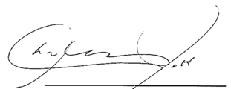
Charles M Pitt  C M PITT & CO  CHARTERED ACCOUNTANTS | CA ANZ Membership No. 20180  Registered Association Auditor No. 2944  Unit 6 & 7, 2 Philip Street Strathfield

Date: 12 May 2021

Liability limited by a scheme approved under Professional Standards Legislation

SYDNEY UNIVERSITY POSTGRADUATE REPRESENTATIVE ASSOCIATION
STATEMENT OF COMPREHENSIVE INCOME
FOR THE YEAR ENDED 31 DECEMBER 2020
Page 19
 | Note | 2020  $ | 2019  $
Income
University Funding |  | 1,946,423 | 1,868,635
Emergency response funds |  | 25,000 | -
Interest received |  | 178 | 5,056
Sundry Income |  | 12,942 | 3,419
Cashflow Boost |  | 100,000 | -
Funds Carried forward |  | (97,567) | (151,159)
Funds Brought forward |  | 151,159 | 207,000
Total Income |  | 2,138,135 | 1,932,951
Expenses
Employment Expenses
Salaries and Wages
Administration Salaries |  | 431,217 | 422,378
Administration Superannuation |  | 49,220 | 42,292
Casual elections Salaries |  | - | 11,458
Casual elections Superannuation |  | - | 818
Student Advisors' Salaries |  | 635,107 | 566,075
Student Advisors' Superannuation |  | 78,496 | 61,813
Total salaries and wages |  | 1,194,040 | 1,104,834
Stipends
Disabilities Officer's Stipend |  | 5,398 | 10,017
Disabilities Officer's Superannuation |  | 513 | 952
International Student Officer's Stipend |  | 20,049 | 16,957
International Student Officer's Superannuation |  | 1,923 | 1,610
Education Officer's Stipend |  | 29,688 | 26,059
Education Officer's Superannuation |  | 2,820 | 2,476
Satelite Officer's Stipend |  | 7,711 | 9,246
Satelite Officer's Superannuation |  | 733 | 915
President's Stipend |  | 50,123 | 50,823
President's Superannuation |  | 4,762 | 4,829
Student Publication Director's Stipend |  | 19,443 | 19,708
Student Publication Director's Superannuation |  | 1,847 | 1,872
Amount brought forward to page 19 |  | 145,010 | 145,464

SYDNEY UNIVERSITY POSTGRADUATE REPRESENTATIVE ASSOCIATION
STATEMENT OF COMPREHENSIVE INCOME
FOR THE YEAR ENDED 31 DECEMBER 2020
Page 20
 | Note | 2020  $ | 2019  $
Amount carried forward |  | 145,010 | 145,464
Queer Officer's Stipend |  | 2,892 | 6,878
Queer Officer's Superannuation |  | 275 | 653
Secretary's Stipend |  | 29,895 | 30,307
Secretary's Superannuation |  | 2,840 | 2,774
Treasurer's Stipend |  | 19,939 | 19,814
Treasurer's Superannuation |  | 1,883 | 1,882
Vice President's Stipend |  | 29,798 | 21,246
Vice President's Superannuation |  | 2,824 | 2,123
Women Officer's Stipend |  | 15,849 | 11,215
Women Officer's Superannuation |  | 1,506 | 1,029
Total Stipends |  | 252,710 | 243,387
Other Employment Expenses
Employee Benefits |  | 109,598 | 27,200
Payroll Management Systems |  | 7,018 | 6,567
Payroll Tax |  | 18,600 | 38,845
Staff Development and Training |  | 3,654 | 16,752
Staff Recruitment |  | - | 590
Staff Support & supervision |  | 6,709 | 8,266
Staff Travel, Meals & Accommodation |  | 1,079 | 3,388
Workers Compensation Insurance |  | 10,585 | 10,830
Sundries |  | 346 | 1,358
 |  | 157,589 | 113,796
Total Employment Expenditure |  | 1,604,339 | 1,462,016
Administration Expenses
Accounting & Bookkeeping |  | 700 | 3,960
Audit | 8 | 8,200 | 8,200
Bank Charges |  | 166 | 215
CAPA Affiliation fee |  | 21,818 | 23,636
CISA Affiliation fee |  | 440 | 440
Amount brought forward to page 20 |  | 31,324 | 36,452

SYDNEY UNIVERSITY POSTGRADUATE REPRESENTATIVE ASSOCIATION
STATEMENT OF COMPREHENSIVE INCOME
FOR THE YEAR ENDED 31 DECEMBER 2020
Page 21
 | Note | 2020  $ | 2019  $
Amount carried forward |  | 31,324 | 36,452
Computer Expenses |  | 1,874 | 1,015
Insurance |  | 4,342 | 4,195
Lease Equipment (Photocopier) |  | 21,700 | 20,387
Legal Expenses |  | - | 1
Legal Expenses - Redfern Legal Centre |  | - | 54,432
Supra Legal Funding |  | 160,000 | 40,000
Office Amenities |  | 2,367 | 3,084
Office Equipment (Non IT) |  | - | 2,129
Office Refurbishment |  | - | 2,548
Postage & Courier |  | 119 | 8
Printing & Stationery |  | 4,563 | 8,344
Subscription |  | 3,719 | 2,623
Telephone |  | 1,243 | 365
Translation Expenses |  | 28 | 72
ATO & NSW Revenue Penalty |  | - | 538
Website Development |  | 1,345 | 7,349
 |  | 232,625 | 183,541
Activities & Functions
Activities & Functions |  | 4,709 | 7,841
Campaigns |  | 1,895 | 14,295
Outreach/ Grad ball |  | - | 18,259
Supervisor of year award |  | 3,392 | 2,751
Council Meeting & AGM Expenses |  | 6,500 | 8,748
Councillor Conference Attendance (including airfares) |  | - | 15,382
Welcome Week |  | 7,295 | 17,565
 |  | 23,791 | 84,841
Publications
Calendar |  | 1,695 | 3,258
Information brochures / books |  | 2,792 | 5,829
Sundry |  | - | 638
Social Media |  | 6,662 | 2,886
 |  | 11,149 | 12,611

SYDNEY UNIVERSITY POSTGRADUATE REPRESENTATIVE ASSOCIATION
STATEMENT OF COMPREHENSIVE INCOME
FOR THE YEAR ENDED 31 DECEMBER 2020
Page 22
 | Note | 2020  $ | 2019  $
Contestable funding
Legal Services |  | 80,000 | 80,000
Social Functions |  | 1,117 | 9,829
Health & Fitness |  | 10,943 | 31,031
Westmead Outreach |  | 805 | 4,459
Lunchtime Info Free BBQ |  | 1,109 | 7,551
COVID 19 Postgrad support |  | 11,930 | -
 |  | 105,904 | 132,870
Special projects
SOS conference |  | 8,298 | 793
CISA conference |  | - | 725
Policy review |  | 1,632 | 35,000
Peer Connect |  | 262 | 9,074
Student Leadership Community |  | 5,120 | 12,239
 |  | 1,542 | 1,527
Online Election |  | 10,564 | 1,000
SUPRA 50th Anniversary |  | 7,850 | -
Promotional Material |  | 28,420 | -
 |  | 63,688 | 60,359
Total Expenditure |  | 2,041,496 | 1,936,238
Income/ (Deficit) from ordinary activities |  | 96,640 | (3,287)

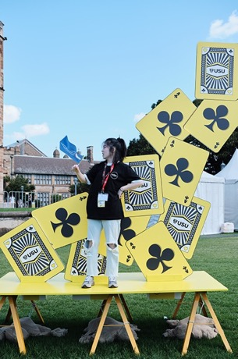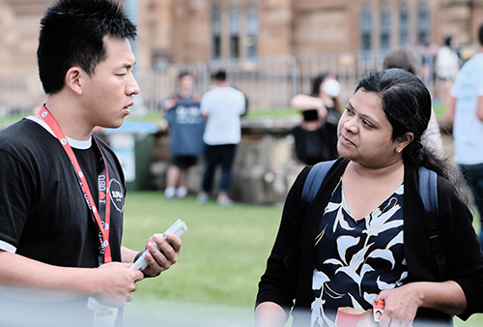

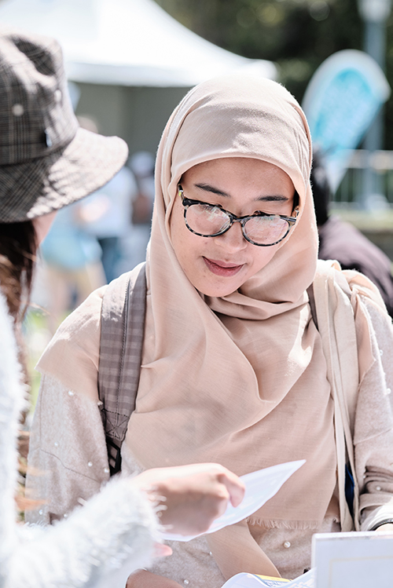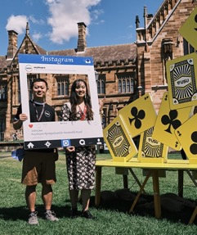

SUPRA 2020

Students working for students

